

**ONLINE SHOPPING PLATFORM FOR STUDENTS, TEACHERS AT FPTU**

**Software Design Document**

– HoChiMinh, September 2022 –

**Table of Contents**

I. Overview 3

1. Code Packages 3

2. Database Schema 3

II. Code Designs 4

1. <Feature/Function Name1> 4

a. Class Diagram 4

b. Class Specifications 4

c. Sequence Diagram(s) 4

d. Database queries 5

2. <Feature/Function Name2> 5

III. Database Tables 5

1. <Table name 1> 5

2. <Table name 2…> 5

# I. Overview

## 1. Code Packages/Namespaces

*[Provide the package diagram for each sub-system. The content of this section including the overall package diagram, the explanation, package and class naming conventions in each package. Please see the sample and description table format below – following Java project naming convention]*

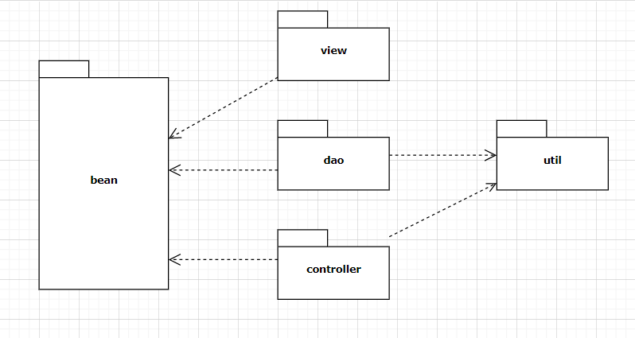

***Package descriptions & package class naming conventions***

|  |  |  |
| --- | --- | --- |
| **No** | **Package** | **Description** |
| 01 | bean | * Entity class * Classname + “DTO” (ex: ProductDTO.java) |
| 02 | view | * Is used for holds view for user and admin * lowerCase (ex:mainpage.jsp) |
| 03 | controller | * Is used for holds web controllers in MVC 2 models * Classname + “controller” (ex: HomeController.java) |
| 04 | dao | * Is used for holds class * Classname + “DAO” (ex: ProductDAO.java) |
| 05 | util | * The util methods should be moved to a helper or utility class or encapsulated within the class that uses them * Camelcase (ex: myToy.java) |

## 

## 

## 

## 

## 2. Database Schema

*[Provide the tables relationship like example below – following MySQL database naming convention]*

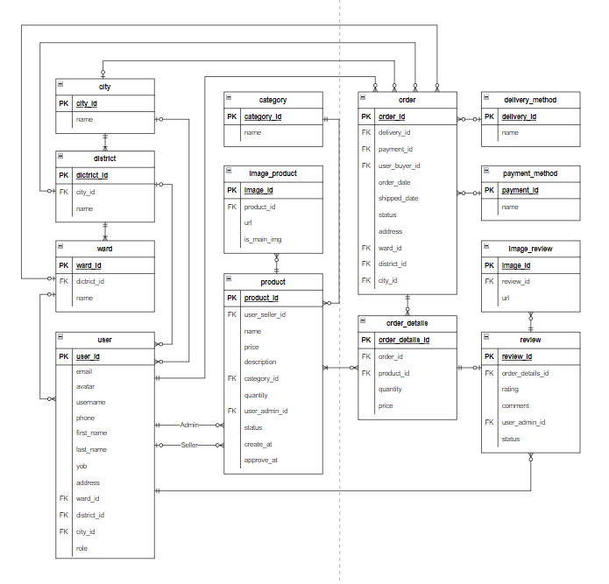

***Table descriptions & package class naming conventions are as below***

|  |  |  |
| --- | --- | --- |
| **No** | **Table** | **Description** |
| 1 | user | - Primary keys: user_id  - Foreign keys: ward_id, district_id, city_id |
| 2 | product | - Primary keys: product_id  - Foreign keys: user_seller_id, category_id, user_admin_id |
| 3 | order | - Primary keys: order_id  - Foreign keys: delivery_id, payment_id, user_buyer_id, ward_id, district_id, city_id |
| 4 | order_detail | - Primary keys: order_detail_id  - Foreign keys: order _id, product_id, review_id |
| 5 | category | - Primary keys: category_id |
| 6 | image_product | - Primary keys: image_id  - Foreign keys: product_id |
| 7 | delivery_method | - Primary keys: delivery_id |
| 8 | payment_method | - Primary keys: payment_id |
| 9 | review | - Primary keys: review_id  - Foreign keys: user_admin_id, order_detail_id |
| 10 | image_review | - Primary keys: image_id  - Foreign keys: review_id |
| 11 | ward | - Primary keys: ward_id  - Foreign keys: district_id |
| 12 | district | - Primary keys: district_id  - Foreign keys: city_id |
| 13 | city | - Primary keys: city_id |

# II. Code Designs

## 1. <Feature/Function Name1>

*[Provide the detailed design for the function <Feature/Function Name1>. It include Class Diagram, Class Specifications, and Sequence Diagram(s)]*

### a. Class Diagram

*[This part presents the class diagram for the relevant feature]*

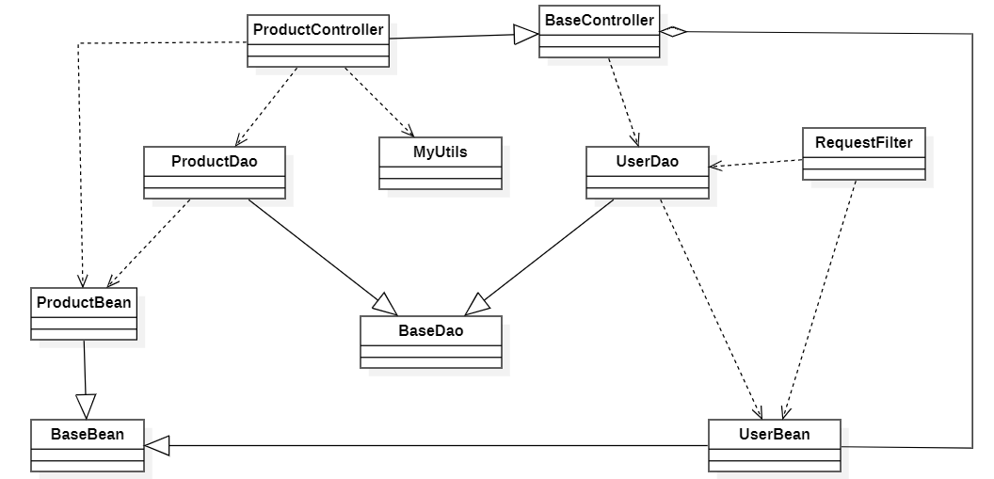

### b. Class Specifications

*[Provide the description for each class and the methods in each class, following the table format as below]*

#### XYZ Class

*[Provide the detailed description for the class methods]*

|  |  |  |
| --- | --- | --- |
| **No** | **Method** | **Description** |
| *01* | *<method name>* | *<Description of the method, including the inputs, outputs & internal method processing>* |
|  |  |  |

#### ABC Class

***Class Methods***

*[Provide the detailed description for the class methods]*

|  |  |  |
| --- | --- | --- |
| **No** | **Method** | **Description** |
| *01* | *<method name>* | *<Description of the method, including the inputs, outputs & internal method processing>* |
|  |  |  |

### c. Sequence Diagram(s)

*[Provide the sequence diagram(s) for the feature, see the sample below]*

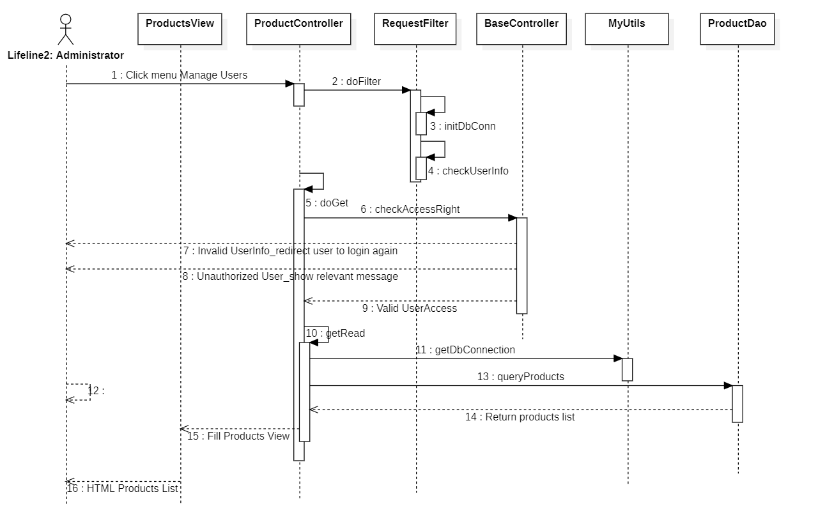

### d. Database queries

*[Provide the detailed SQL (select, insert, update...) which are used in implementing the function/screen]*

## 2. <Feature/Function Name2>

…

# III. Database Tables

## 1. <Table name 1>

*[Give some lines about the table here>>*

*[Table fields, in the form of table format as below]*

|  |  |  |  |  |  |  |  |
| --- | --- | --- | --- | --- | --- | --- | --- |
| **#** | **Field name** | **Type** | **Size** | **Unique** | **Not Null** | **PK/FK** | **Notes** |
| 1 | Field name1 |  |  |  |  |  |  |
| 2 | Field name2 |  |  |  |  |  |  |

## 2. <Table name 2…>